The cost of no Europe: costs and consequences of localized or centralized assessment of relative efficacy
Issues Panel Session: ISPOR 18th Annual European Congress
Tuesday 10 November 2015
Executive Summary
Despite attempts to harmonize access to medicines for patients in Europe by numerous organizations including the European Commission, EUnetHTA, industry organizations, and patient groups, heterogeneity in Health Technology Assessment (HTA) evaluation of medicines across Member States continues to create inconsistent access decisions. The objective of the Issue Panel was to discuss where convergence efforts should be focused, and what level of harmonisation might be viable from the perspective of Member State autonomy. An analysis of the extent of HTA convergence in Europe provided context for the session, followed by both Industry and Member State views on convergence and cooperation on HTA.
With over 170 people in attendance, the Issue Panel addressed key issues relating to HTA heterogeneity and cooperation efforts across Europe. Among the key themes, two were identified as priority areas:
- Patient centricity: The importance of the patient perspective was emphasized, particularly equitable access to medicine across Europe and representation of the patient voice in decision-making. There was strong agreement that the patient is a key and vitally important stakeholder, likely under represented today, and should be more directly considered in HTA assessments. The importance of collecting high quality patient reported outcomes (PROs), quality of life (QoL) measures and functional outcomes measures was emphasised; these are the measures that translate into what determines how a patient will function better. New ways of collecting PROs, such as social media data, were suggested. Real world evidence (RWE) is a potentially valuable approach for providing evidence relating to the patient experience and QoL. The panel recognized that further work needs to be done to advance relevant patient measures, as a priority area within HTA cooperation.
- Personalized medicine: Biomarker and genomic analyses are playing an increasingly strong role in pharmaceutical R&D, leading to the development of new targeted medicines; HTA needs to have the in-built flexibility to support optimal evaluations of these innovative products. The assessment of genomics / biomarker-driven sub-populations, budget impact, willingness to pay, equity and value based pricing are just a few of the challenges faced in this new era of medicine.
Other Key themes:
- Focus areas for a harmonised system: evaluation vs. implementation: There was agreement that not all aspects of HTA and access to medicines can or should be addressed at a European level. There was strong concurrence that evidence evaluation could benefit from being conducted at the European level and a coordinated approach to relative efficacy assessments should continue to be piloted and progressed. However, due to inherent differences in medical practice, healthcare systems and country economics, it was deemed that certain aspects such as cost effectiveness and implementation should be determined at a country level.


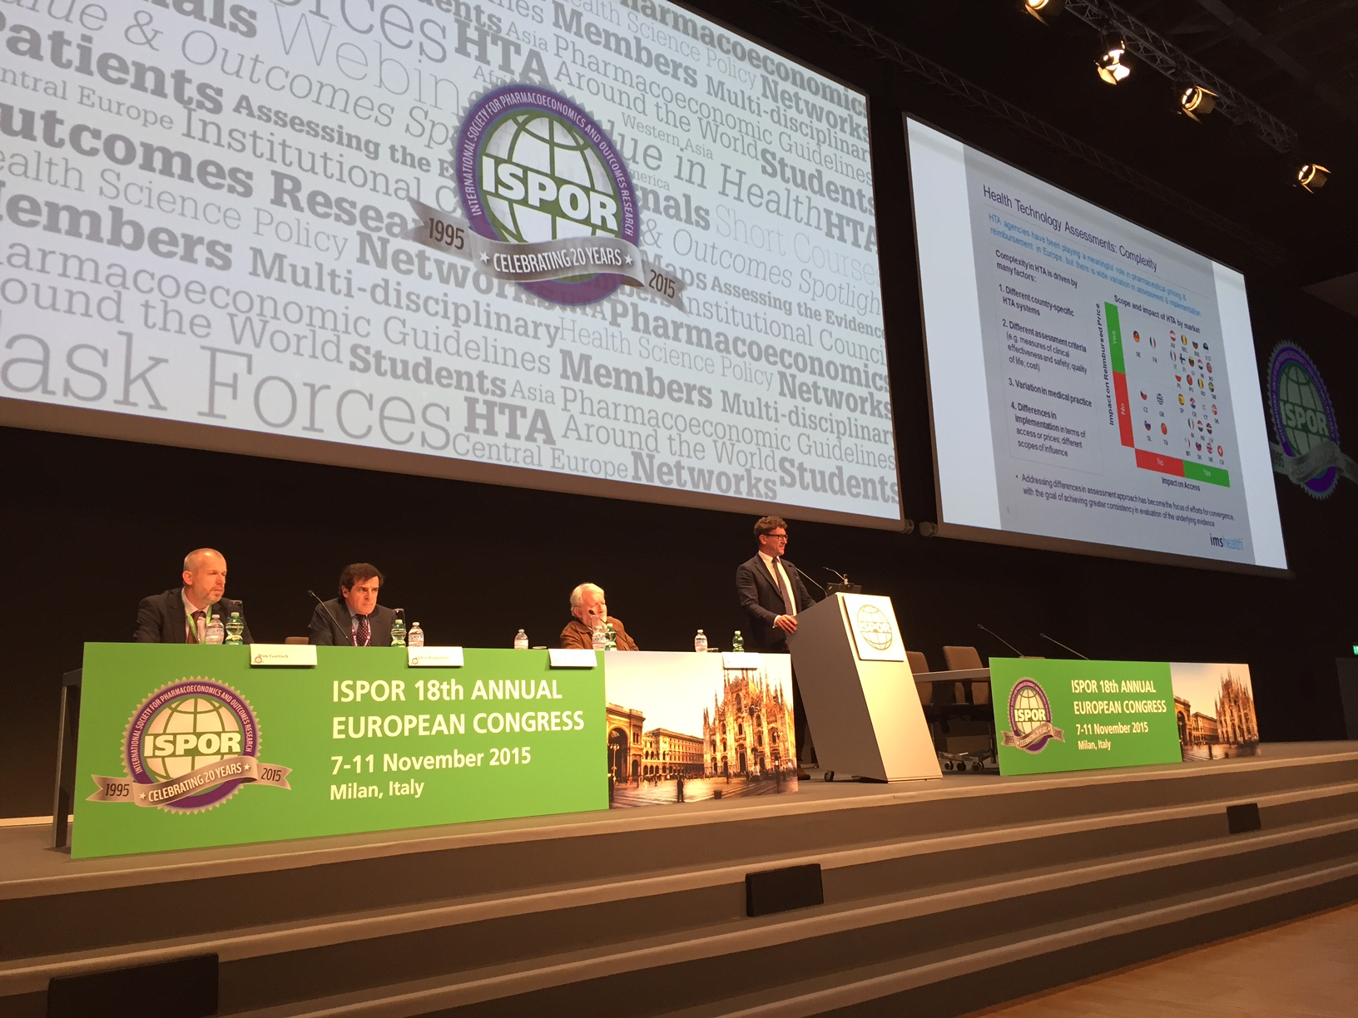
Issues Panel Session: Issue Panel Session Speakers at the ISPOR 18th Annual European Congress: (l-r) Wim Goettsch, Andrea Rappagliosi, Alastair Kent, Jacco Keja
- Benefits of cooperation for challenging measures, such as evaluation of clinical endpoints & sub-populations: Certain components of assessments that are more susceptible to interpretation, such as surrogate endpoints, tend to be interpreted differently by each HTA agency. This suggests that these components may not be well understood, and could benefit from discussion and alignment among HTA agencies. Furthermore, differences exist between countries in the value and weight placed on softer clinical endpoints and the inclusion of sub-group analysis leading to differences in evaluation of medicines.
Further, in the discussion, several topics emerged where there was alignment among the panellists, areas where further work was needed to address specific issues, and potential topics that were expected to pose challenges for achieving cooperation in HTA and relative efficacy assessments (REA).

Areas of alignment
- Existence of patient access inequities, in part as a result of heterogeneity and inconsistencies in HTA assessments in different countries; importance of the patient view for HTA, which is not optimally incorporated today
- Perceived benefit of European REA as an approach to address challenges of divergence; cooperation could reduce duplication in HTA assessments, not only creating consistencies, but also efficiencies for Member States
- Recognition that some elements should continue to be assessed at the country or local level due to inherent differences between European countries or regions
- Increased trust between Member States, Industry and HTA agencies as being critical in achieving greater cooperation and alignment
- Timeliness of reports as being critical to enable re-use by agencies and to avoid creating a further barrier for timely patient access

Areas requiring further evaluation
- How to improve the quality of PROs and QoL measures, including functional outcomes
- How to address sub-populations in a coordinated approach, where the underlying epidemiology or unmet need may vary across markets. The relevance of this is even more important given the genomics revolution and advent of personalized medicine
- How to further continue and expand on the EUnetHTA pilots and progress further implementation
- The use of RWE in contributing to evaluation of medicines, especially RWE with an angle on genomics, and patient centric endpoints

Areas representing potential challenges
- Overcoming historical trust issues between stakeholders
- Establishing viable mechanisms for cooperation while recognizing and accounting for underlying differences, such as health systems, clinical pathways, languages, values
- Gaining commitment and alignment among Member States, including appropriate representation of smaller countries
- Possibility of developing consistent methodologies and perspectives on evaluating sub-populations and softer clinical endpoints where there is strong variation in interpretation today
- Alignment with other stakeholders that also require evidence, such as regulatory agencies and clinical guideline development bodies (national and international)

Overview of Issues Panel
With over 170 people in attendance, the Issue Panel was presented by key thought leaders representing Genetic Alliance UK (Patient view), IMS Health (Analysis of HTA Convergence), Sanofi Pasteur MSD (Industry view), and Zorginstituut Nederland (Member State view).
Introduction | Alastair Kent, OBE, Genetic Alliance UK, London, UK
Recent HTA decisions | Jacco Keja, PhD, IMS Health, Rotterdam, The Netherlands
Industry view | Andrea Rappagliosi, LLM, Sanofi Pasteur MSD, Lyon, France
Member State view | Wim Goettsch, EUnetHTA JA2, Zorginstituut Nederland
- Alastair Kent, Genetics Alliance, opened the session by providing a patient perspective, focusing on access to medicines and the patient as a key stakeholder in the discussion regarding a coordinated approach to European HTA. However, it was noted that there can be benefit to differential access across Europe in that a “no” in one country is not a “no” for everyone; positive evaluations and access to a medicine in one country allows for the development of RWE to be provided to others, which can contribute to a change in decision; a coordinated approach should not create further challenges for patient access.

- Jacco Keja, IMS Health, presented an analysis of the extent of convergence in HTA across Europe and factors contributing to the observed heterogeneity. Complexity in HTA is driven by many factors such as country-specific HTA systems, variations in assessment criteria, variation in medical practice and differences in implementation. Due to inherent country differences affecting implementation, it was discussed that assessment, particularly around efficacy, may be most appropriate for the focus of efforts for convergence.

Jacco presented the results of an analysis of recent HTA assessments for four recent launches in Multiple Sclerosis conducted by IMS. Key factors contributing to divergence in HTA decisions across Europe were the nature of the therapeutic area, the nature of the clinical endpoint and the comparator selection. The case study highlighted differences in HTA decisions in different countries which would result ultimately in differential patient access to innovative therapies. The level of coordination that a European level HTA approach should allow was discussed; it was suggested that a coordinated evaluation of clinical evidence could be beneficial, even if country-specific decisions regarding implementation remain.

- Andrea Rappagliosi, Sanofi Pasteur MSD, presented the industry view highlighting the need for European REAs to improve patient access to medicines, providing examples of pilot initiatives and lessons learned to date in this area.

Andrea explained that while “a disease is a disease, and a product is a product,” these factors are not necessarily treated the same, and depend on the geography of a patient within Europe. The fact that clinical assessments are not viewed as a constant, leads in turn to inequality in patient access to medicines. It was described that the REAs could and should be centralised, whilst still allowing for local considerations where necessary in aspects such as local issues related to the health problem, the local treatment pathway and economic considerations. The benefits of this approach, for the healthcare system and for industry were discussed, where by a coordinated approach would reduce the duplication in activities. A number of pilots, currently or previously underway, were presented. Based on these pilots, some process and methodology improvements have been recommended, including need to utilise transferrable information between countries. Timing is also critical to maximize utility and re-use of the report.

- Wim Goettsch, Zorginstituut Nederland, presented the Dutch Member State experience and view on a convergent HTA approach, including previous pilots that The Netherlands had been involved with in this area.

The benefits of a coordinated approach to HTA was described, including the decrease in duplication on HTA assessments, and the end result of consistency between different national HTA assessments. However, Wim noted that whilst evidence evaluation can be undertaken at the European level, decisions on reimbursement should be made on a national level.

Wim described how The Netherlands has been active in three of the European pilots: zostavax, canagliflozin and ramucirumab. In one of the pilots, The Netherlands had used an adapted version of a EUnetHTA report with positive feedback from the assessing body who reported a reduction in time to assess compared to the usual methodology. Wim stressed the importance of trust, whereby individual Member States may question the need to collaborate with others when their individual process and quality has already been established. Wim noted that with experience, there has been growing internal trust in the quality and consistency of the EUnetHTA REA reports.

Decision maker support was cited as being critical to success of a cooperative European approach; in the Netherlands there is explicit support from the Minister for Health for European reports. In addition, Wim highlighted the issue of country size in determining the approach and the fact that this will likely be driven by the larger European countries. It was suggested that smaller countries should coordinate to provide a stronger voice in conjunction with the larger countries.

Audience Question
“What do you think of a pan-European approach to HTA?”
Beneficial | ~80% | 
Leads to too much bureaucracy and technical complication | ~5% | 
No opinion/ unknown | ~15% | 

Discussion Points

The Issues Panel stimulated questions and discussions related to a variety of themes.

Dr. Neha Rai, from Novartis, asked the panel about the role of biomarkers in evidence evaluation, and whether they thought that PROs should be considered at the country-level. This opened up an interesting discussion:

- Wim discussed the EUnetHTA clinical guidelines regarding endpoints but highlighted that fact that there may be different interpretations across Europe; this is an area that still needs further work and exploration. The area of genomics and personalised medicine is growing an attracting great interest, but it seems to be provided investment by industry primarily now. Wim noted that the sub-population evaluation was considered in the European pilot for zostavax, but concluded that sub-population evaluation may be difficult to conduct at a level higher than national.

- Wim also discussed quality of life data and how its interpretation and data quality can be mixed. This suggests there is further work and analysis required in this area. Jacco agreed with this suggestion and confirmed the view that there can be substantial variation in the consideration of PROs and quality of life data in HTA. He cited the German example as being the most extreme in not using these data in evaluation. The importance of collecting high quality PROs, QoL measures and functional outcomes was emphasised: these are the measures that translate into what determines how a patient will function better in their real life.

- It was agreed that the patient perspective is extremely valuable and should be considered in HTA evaluation, however, Andrea suggested that PROs collected from a clinical trial may not fully reflect the real patient experience. This idea was further confirmed by Wim who noted that patient groups have advocated further development of PRO instruments, as they currently may not fully reflect what is important and impactful to the patient. Thus, the importance of developing or using appropriate tools and using innovative data collection methodologies to obtain high quality PROs, QoL measures and functional outcomes was emphasised. Innovative ways to gather data, such as social media data collection and other RWE should be utilised to best capture the true patient experience. It was felt that a more coordinated approach to collecting these data is required, thus, this is an important area to consider in HTA cooperation.

